PROJECT DOCUMENTATION: Task Owners:

Shiva Tiwari, Nishant Atal, Brundavani,

Vangala Keerthana, Sahithi yerramsetty,

Vibhaw.

**1.2 FRONTEND**

**1.2.1 Flask structure and Flask templates, dockerization**

These are the images of the output using Streamlit. To run the app, you need streamlit and run filename.py command.

Streamlit is an open source Python library that allows us to create web app for Data Science and Machine learning with minimal efforts.

To use Streamlit library, Install it using pip, add the import statement. The code snippet is a simple example of creating a button. Once you’re done with code, run the app with the snippet at the end. It runs and provides a URL in which our app will run and can be viewed in any browser.

**Streamlit Implementation for TechDocs Application**

**1.2.3 Welcome Screen - Home Page**

This is the Welcome Screen Page for TECHDOCS.

**1.2.4 Sign-in page/Forgot password**

This is the Forgot Password page. If a person forgot their password while login, they can click to Forgot password and the page will open automatically. Firstly, fill in the email id and then reset your password by writing New Password and confirm it. It will reset.

**1.2.5 Registration page**

This is the Registration Page to register and if a person already registered then just Login by filling username and password

**1.2.6 User's Dashboard – Home:-**

Dashboard:

This is the Dashboard for a user of TechDocs and user’s profile page.

User Profile:

**1.2.7 Client side local storage**

* While creating a document user might want to work offline in case he/she goes to a remote place. For this they might require the document available offline.
* In such cases user is allowed to download the document which they have made and then they can work offline on it.

**1.2.8 Plans and subscriptions page**

* Plans and subscription page shows the available type of plans and subscription in which the users can subscribe according to their needs.
* Each plan allows users respective access to the application.
* For Free or Standard users they are allowed to use limited functionality of the application like Spell Check, Search functionality etc.
* For Premium users, they may be allowed more functionalities including the functionalities which are allowed to free users like Sharing Document with others, more storage etc.

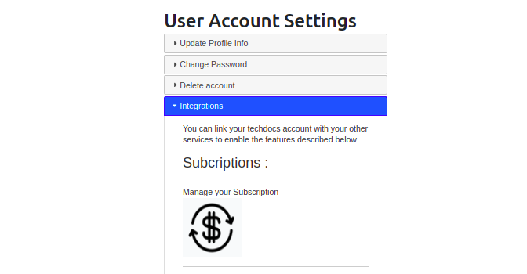

**1.2.9 Product features document page**

* Users would like to know what kind of features is being provided by the application.
* Production Features page will list all features which can be provided by the application like downloading document, sharing with users etc.

**1.2.10 Help and FAQ**

* Most of the users face some challenges while using an application and raise queries regarding the same.
* To help the user with this Help and FAQ page is created.
* This page lists frequently asked questions raised by users and provide them with the answers.

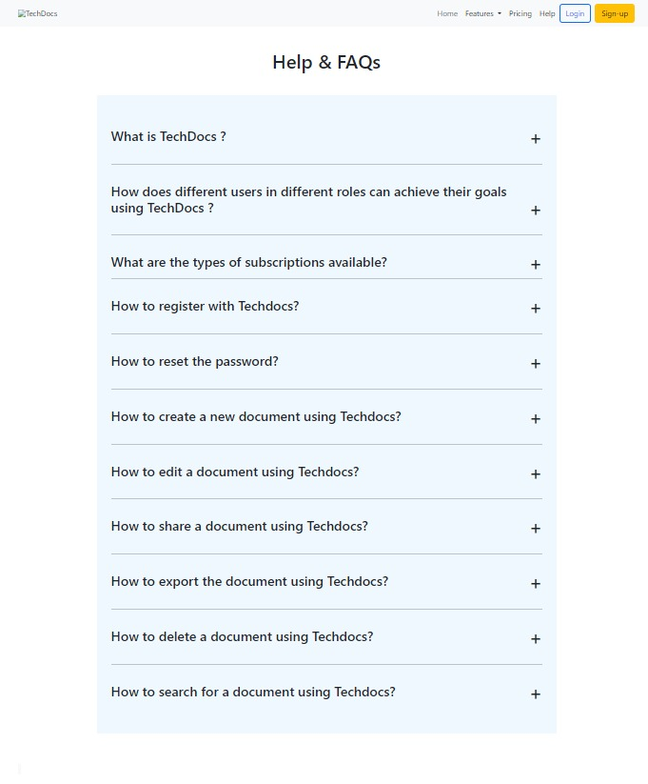

**1.2.11 User Profile Settings**

* Through User Account Setting we can update Profile Information, change password, delete the account if required.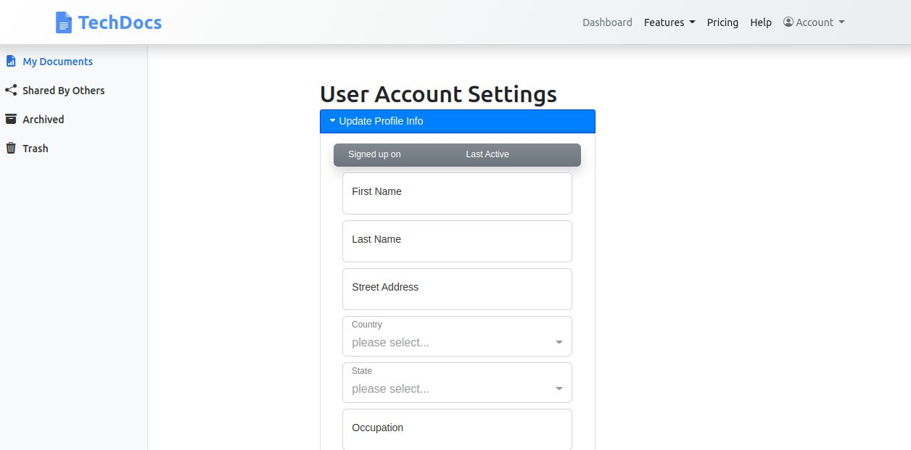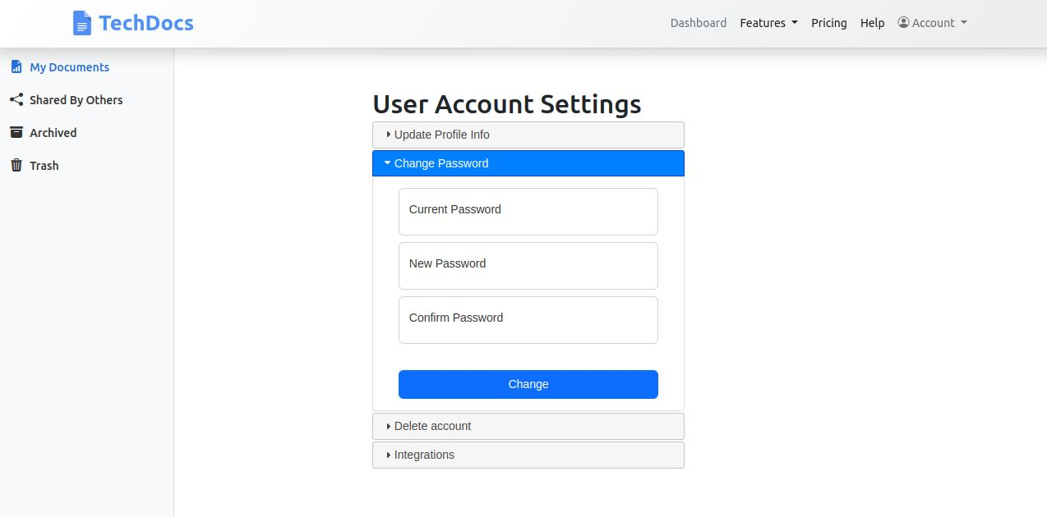
* On the Dashboard page, click New Document enter a name for your project and click on the “tick mark” button to save the file.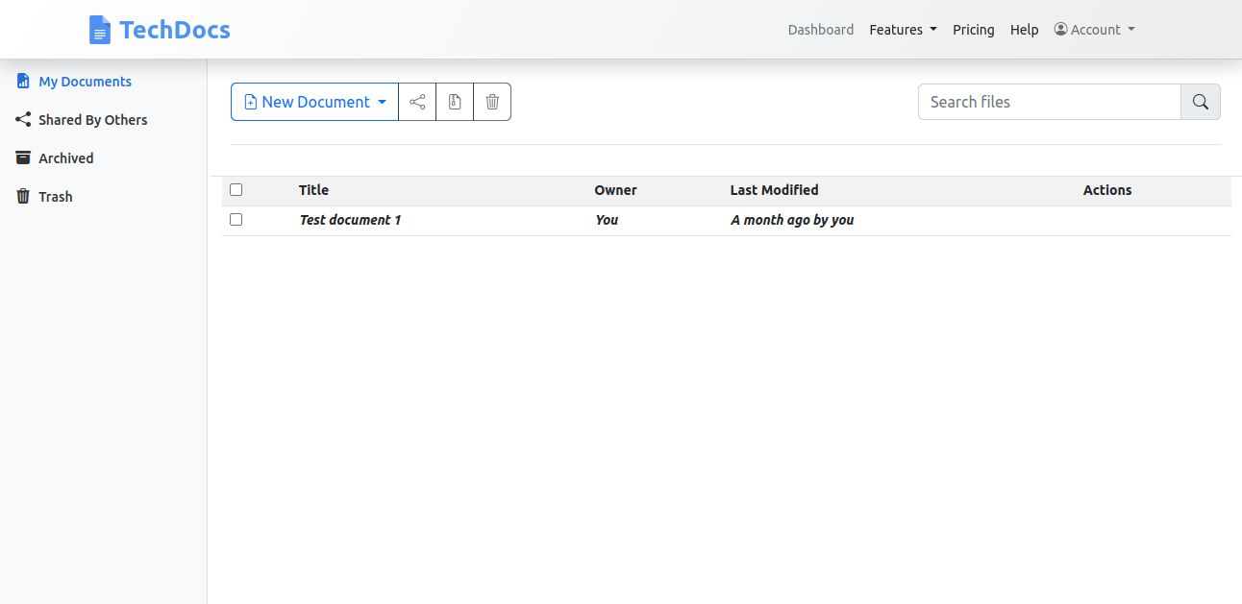

**1.2.12 Latex IDe Page -editor,real time preview**

* Editors are applications to write the Latex code and allow a user to edit and publish the paper in Latex.
* Allows you to create complex documents efficiently and intuitively. Write beautiful and highly customized documents.
* Can Create complex equations, tables, and more. Easily manage your footnotes, references, and bibliographies. Descriptive error messages to help you troubleshoot.
* You can edit your LaTeX documents in TechDocs Dashboard by clicking on the file. It can autosave and you can see the same in preview.

**1.2.14. Latex IDE page - download as pdf**

**Here** are the steps and pictures of the user interface for downloading the documents created above. An event listener is a function in JavaScript that waits for an event to occur and then responds to it. Here we are using it for exporting the created documents. Below are the screenshots of the page click on the download button and it takes you to a new page. There we have an option named download as pdf to save to our system.

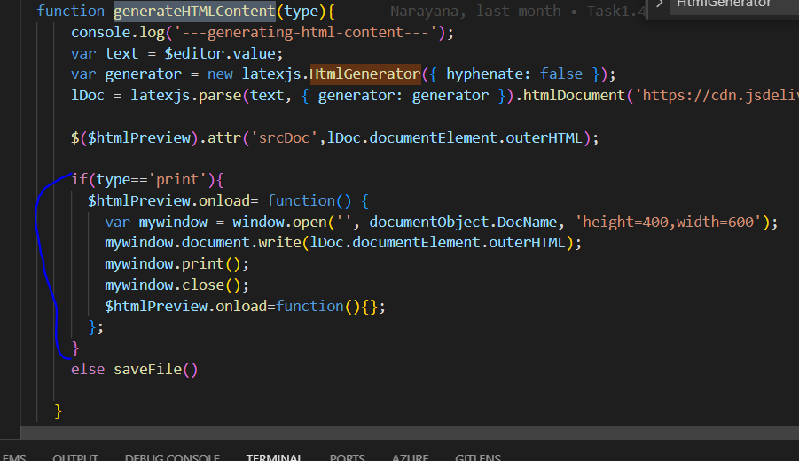

**write content and view output in document**

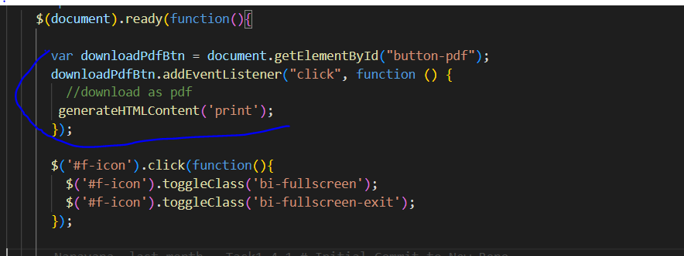

**Download button creation using eventlistner.**

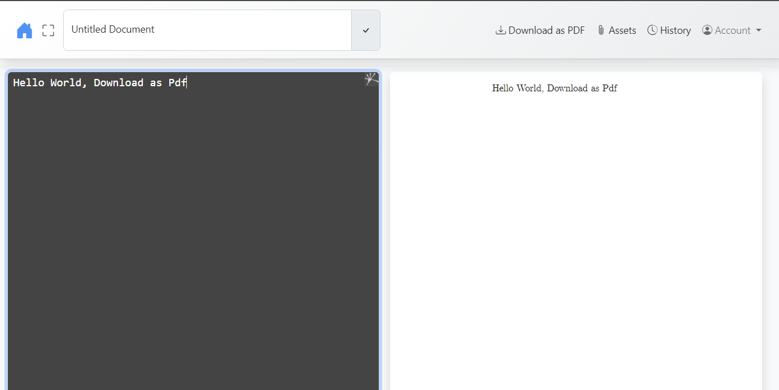

**On clicking the button, you can see a new page where you can download.**

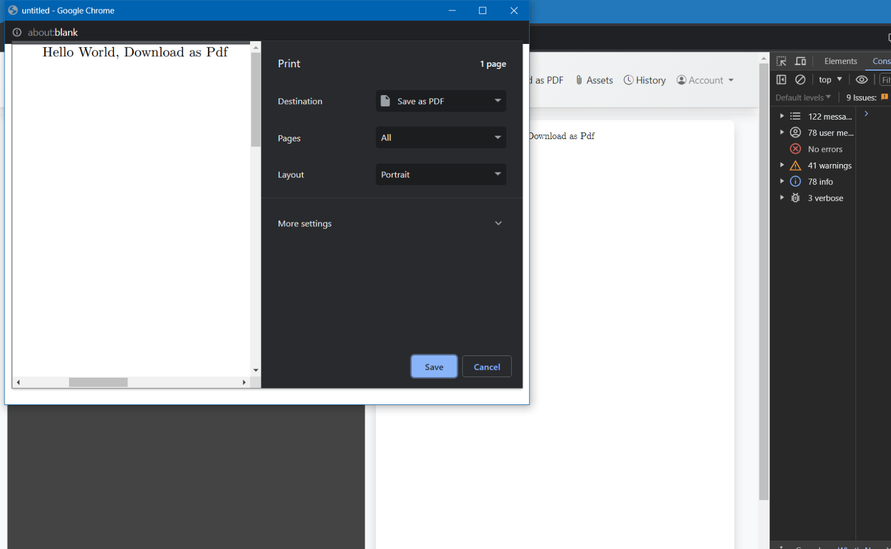

**Click on download as PDF to save it.**

**1.2.15. Latex Templates (Resume and Blank)**

Here is the template creation.

**Steps to run:**

1. Run app.py as shown below

2.Open the dashboard link as shown above

4.Click on Resume Template from the dropdown as shown above.Which will open template as required

5.Click on back button in browser and then click on Blank Template this time

6.Then it will open blank template as shown below which is our requirement.

**1.2.17. Service Worker**

* A service worker is a web worker in web development that acts as a client-side proxy to manage network requests, cache resources, and enable offline capabilities for web applications.
* Service workers are typically written in JavaScript and run in a separate thread, allowing them to run independently of the main browser thread.
* Service workers have access to the Cache API for managing caches, and they use event listeners to respond to various events, such as fetch events, push events, and sync events.
* This service worker uses the Workbox library, which is a set of JavaScript libraries and build tools that make it easy to cache assets, handle network requests, and implement other common service worker functionalities.
* The file name is ../frontend/app/js/sw.js

**1.2.19. Logout**



The drop down ACCOUNT button provides manhy features, amongst them one is logout

Steps to logout

* Nevigate towards the Account button present at the top right corner of the Techdocs user webpage
* Click on the Account button
* Amongs all the various features there is Logout functionality feature present in there
* Nevigate towards it
* Click on it

The logout feature is developed in a very similar fashion to the login feature using HTML, CSS and javascript. When the user proceeds with the logout feature it navigates the user from the user profile current location towards the Techdocs Homepage.

**1.2.20. User's documents page - share document**

* User Documentation page for sharing the documents.
* We have a share button at right corner in user document page, when we click on this a popup appears which is shown in below images.
* In this popup you can mention the recipients email id and share our document.
* We also have “Turn on link sharing” option, using which we can directly share the link to recipients who want to access our document safely.

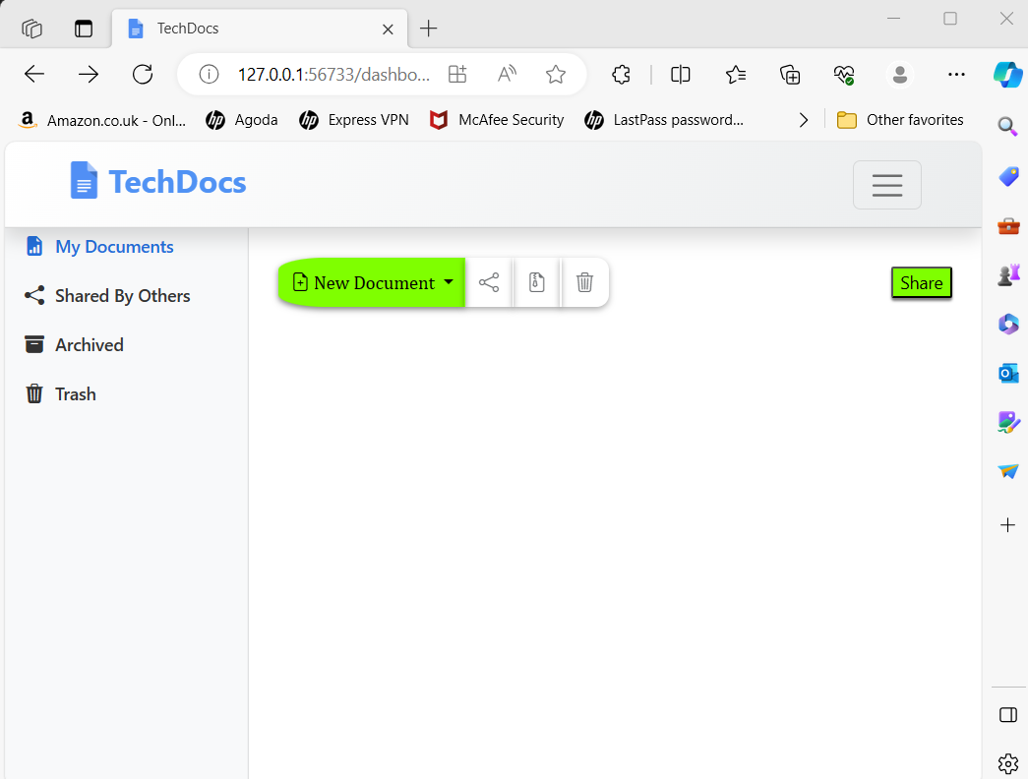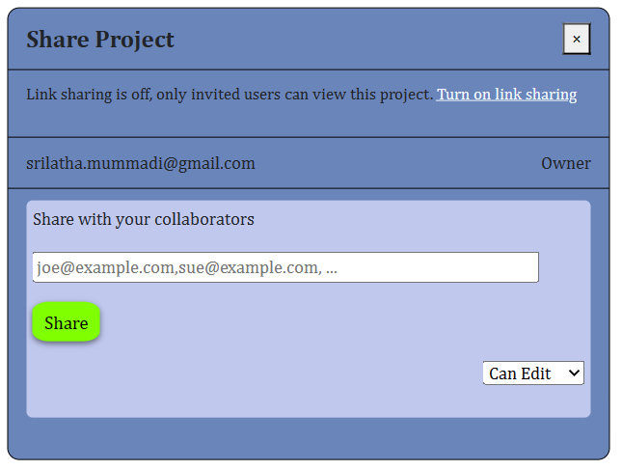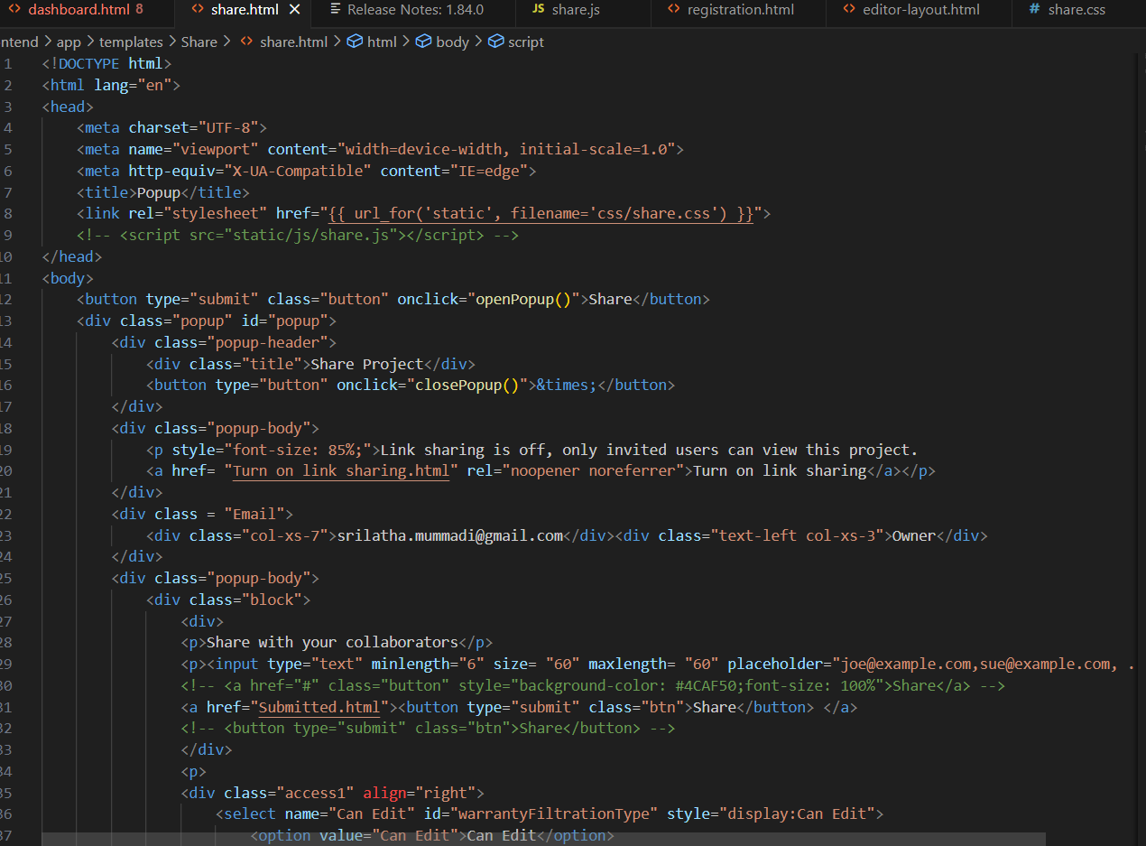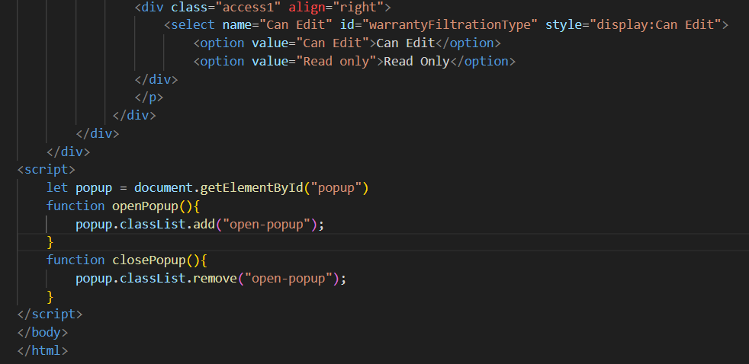

**1.2.21. Trash**

All the Documents which are deleted are moved to the Trash.

To delete the documents on the Trash:

* Click the checkbox on the document and then click on “Delete Permanently”. The document will be deleted permanantly

To Restore the documents on the Trash:

Click the checkbox on the document and then click on “Restore Seletced”. The document will be restored

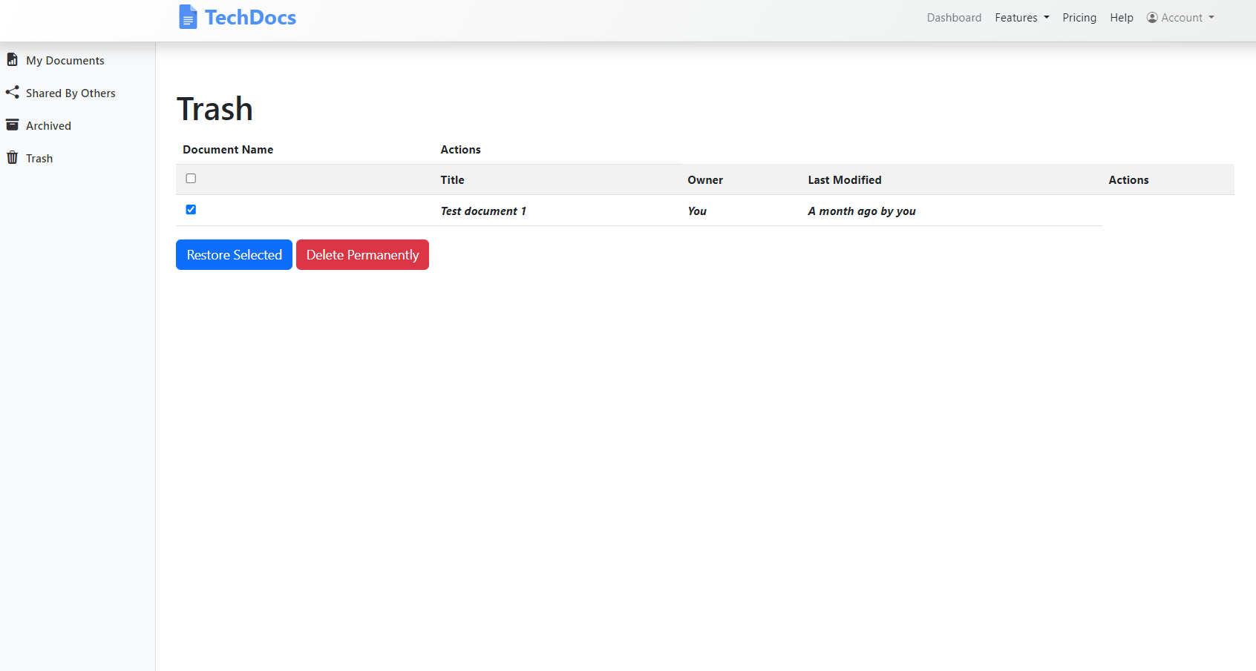

**Trash functionalities:**

Move file to trash:

This service checks if the user has ‘delete’ permission assigned to them and then allows a user to move all versions of a file to trash.

Retrieve file from trash:

Allows a user to retrieve all versions of a file from trash.

Files in trash:

Allows the user to see all the files they have moved to trash.